**Document Name:** Sprint 1 Plan

**Product Name:** MuscleMinder

**Team Name:** FitTech Innovators

**Release Name:** MuscleMinder Launch

**Sprint Completion Date**: 04/23/24

**Revision Number:** 1

**Revision Date:** 04/09/24

Sprint 1 Plan

**Sprint Goal:** The goal of the sprint is to get everyone setup on the github, build our frontend skeleton showing the muscle on a human.

## Sprint 1

* High Priority User Story 1.1 [13 points]: As a fitness enthusiast, I want to see a basic virtual body map so that I can get familiar with navigating my workout visually.
  + Task 1.1.1: Setup a Github repository and setup permissions for PRs (2 hours)
  + Task 1.1.2: Setup and install a React skeleton app and push to repo so everyones is the same (3 hours)
  + Task 1.1.3: Find a library to help us with displaying the muscle groups. (2 hours)
  + Task 1.1.4: Setup a default navbar for future use. (5 hours)
  + Task 1.1.5: Create a map of the muscle system that may involve navigating a react library and modifying it for our use case. (10 hours)

Total for user story 1.1: 22 hours

* Medium Priority User Story 1.2 [5 points]: As a user, I want to hover over muscles on the body map to see their names for educational purposes.
  + Task 1.2.1: Research each muscle group that we need to highlight and hit. (2 hours)
  + Task 1.2.2: On hover, the muscles are highlighted. (2 hour)
  + Task 1.2.3: The muscles will display their muscle group name. (1 hour)

Total for user story 1.1: 5 hours

**Initial task assignment:**

Qays Badri: User Story 1.1, Task 1.1.1

Riksean: User Story 1.1, Task 1.1.2

Safwan: User Story 1.2, Task 1.1.2

Alexander: User Story 1.1, Task 1.1.3

**Initial Burn-up Chart**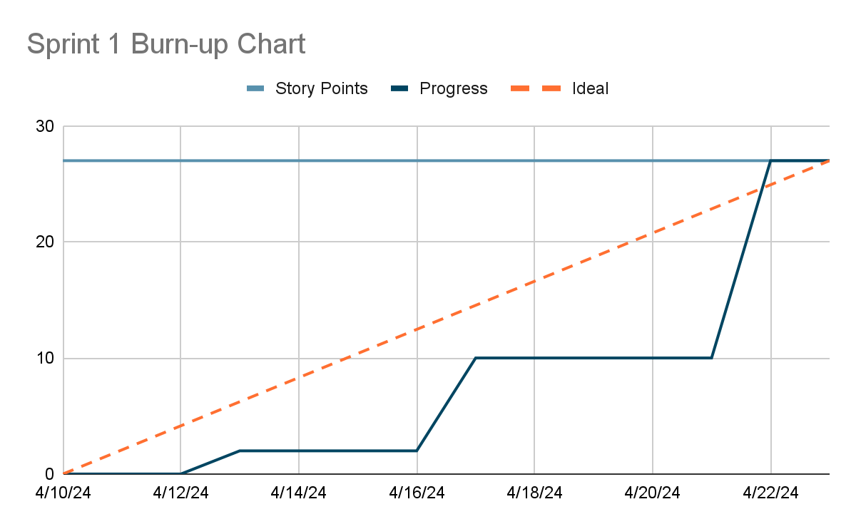

| **Titled User Stories,** | **Tasks Not Started,** | **Tasks In Progress,** | **Tasks Finished** |
| --- | --- | --- | --- |
| * Virtual Body Map * Information on hover |  |  | Task 1.1.1  Task 1.1.2  Task 1.1.3  Task 1.1.4  Task 1.1.4  Task 1.2.2  Task 1.2.3  Task 1.2.1  Task 1.1.5 |

**Scrum Times:**

**Monday: 1:30 pm - 2:15pm**

**Tuesday: 1:30pm - 2pm**

**Wednesday: 1:30pm - 2:30pm (TA Meeting)**

**Thursday: 1:00pm - 2pm**